**SOFTWARE ENGINEERING**

**(IT-303)**

**C-TALK**

User Manual

(Version 1.0)

**Team no: 02**

**Instructor: Prof. Asim Banerjee**

**Team Mentor: Srikant sir, Kiran sir**

**Date: 11 November, 2016**

**Author’s: -**

|  |  |  |
| --- | --- | --- |
| **Name** | **Ro. No.** | **Review** |
| Vipin Kumar Sahu | 201452051 | Shikhar Dhing |
| Anjali | 201452042 |  |

**Team Members:**

|  |  |  |
| --- | --- | --- |
| S.No. | Name | ID |
| 1 | Vipin Kumar Sahu | 201452051 |
| 2 | Kenneth Tenny | 201452066 |
| 3 | Anjali Kumari | 201452042 |
| 4 | Sunny Sankhlecha | 201452061 |
| 5 | Sachin Jangid | 201452060 |
| 6 | Venkata Sandeep | 201452037 |
| 7 | Bhoopendra Singh | 201452020 |
| 8 | Prahalad | 201452052 |
| 9 | Shikhar Dhing | 201452021 |

**Table of Contents**

1. Introduction....................................................................................................4

1.1 Purpose ............................................................................................4

1.2 Scope ……………...........................................................................4

1.3 Authorised User Permissions...........................................................4

2. Product Description........................................................................................5

2.1 Product Perspective..........................................................................5

2.2 Product Functions.............................................................................5

2.3 User Classes………..........................................................................5

3. System Specification.......................................................................................5

3.1 Operating Environment …………………………………………....5

3.2 System Features ……………………………………………………6

3.3 Performance Requirements ………………………………………..6

4. Application Walkthrough ................................................................................7

4.1 Home Screen ………………………………………………………7

4.2 View Answer of the Question……………………………………... 7

4.3 View Login and Signup …………………………………………..8

4.4 Ask new Question …………..……………………………………10

4.5 View Profile ……………………………………………………....11

5. Frequently Asked Questions..……………......................................................12

6. References…………………………………………………………………...14

1. **Introduction**
   1. **Purpose**

* **Preliminary design**—In the preliminary stages of a software development, the need is to size the project and to identify those parts of the project that might be risky or time consuming.
* **Design overview**—As the project proceeds, the need is to provide an overview of how the various sub-systems and components of the system fit together.

In both cases the high-level design should be a complete view of the entire system, breaking it down into smaller parts that are more easily understood. To minimize the maintenance overhead as construction proceeds and the lower-level design is done, it is best that the high-level design is elaborated only to the degree needed to satisfy these needs.

* 1. **Scope**

A high-level design provides an overview of a solution, platform, system, product, service or process. Such an overview is important in a multiproject development to make sure that each supporting component design will be compatible with its neighboring designs and with the big picture.

The High-Level Document (HLD) documentation presents the structure of the system, such as the database architecture. The High-level design document uses non-technical to half technical terms which should be understandable to the administrators of the system. High level design provides a direction for the coders to proceed with guidelines for a software code structure with minimum number of bugs.

* 1. **Authorized User Permissions**

Usage of this software is limited only to the client organisation All About Ads and Team 02, IT303 Software Engineering Summer 2016 IIIT Vadodara.

1. **Product Description**
   1. **Product Perspective**

The product has been designed keeping in mind the requirements of the client. The current problems of the client will be minimised to a great extent with the help of this application. The features of the application have been appropriately designed to fulfill all the client requirements,

* 1. **Product Functions**

We have provided many function like Ask question to the professor, He can answer, Tag the answer, up/down the particular answer, select the TOI. Most important feature is that he will be anonymous.

* 1. **User Classes**

The users of this application will be the teacher and student. There are only two types of privileges:

* General User: The general user can access all the product functionalities like viewing, creating and editing Profile.

1. **System Specifications**
   1. **Operating Environment**

The web application has been designed by Scratched. For database creation we have used mongo DB database and HTML,CSS,JavaScript have been used for web development and front end coding. For Back end coding we are using NodeJS Execution of queries has been carried out with the help of XAMPP.

* 1. **System Features**
* **Login Feature:** The user can login with the registered User ID and his password and can also recover password in case of loss.

* **Ask Question/Give Answer:** The user can Ask Question and he can reply to someone’s Question.
* **Upvote/Downvote:** User also upvote or downvote any answer only once. He can also change his TOI.
  1. **Performance Requirements**
* The users will have a unique User ID and password for login.
* The user will also be provided with an option to change password to provide security to the details.

1. **Application Walkthrough**
   1. **Home Screen**

The home screen looks as follows

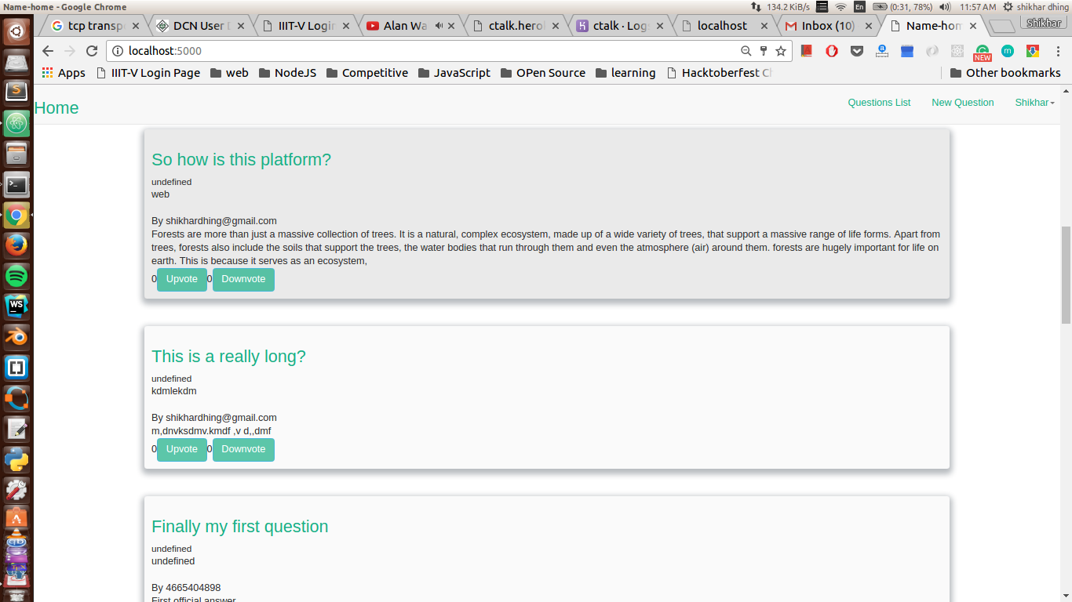

The user has options of searching for an event, creating new events and viewing upcoming events.

* 1. **View Answer of the Question**

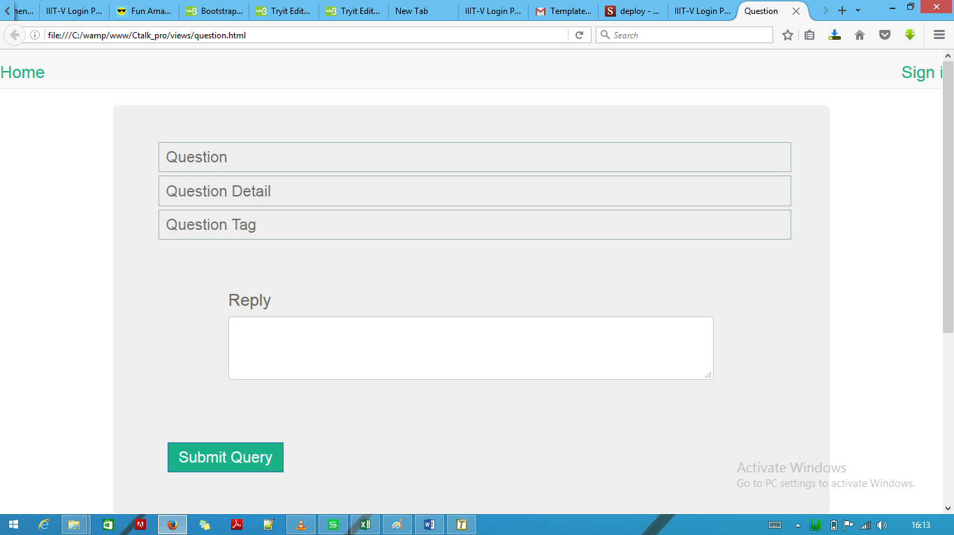

* 1. **View Login and Signup**

Each user is prompted with a login window before they can access any of the system functionalities.

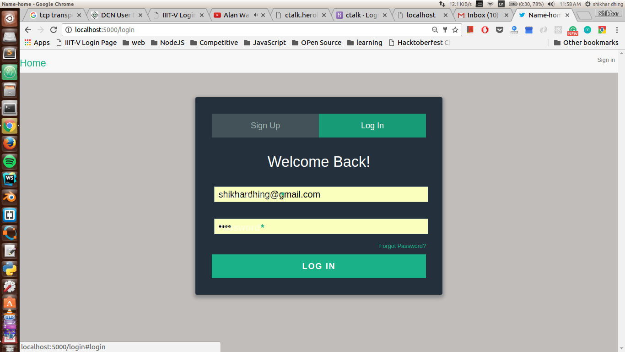

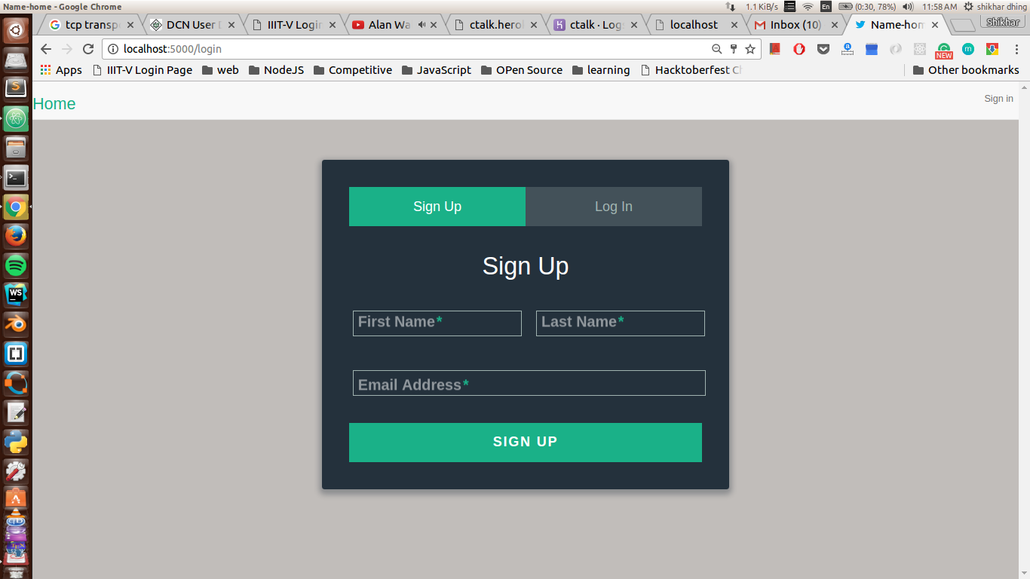

If the user clicks the forgot password button, the user is required to enter the User ID or email address submitted at the time of registration to facilitate password recovery.

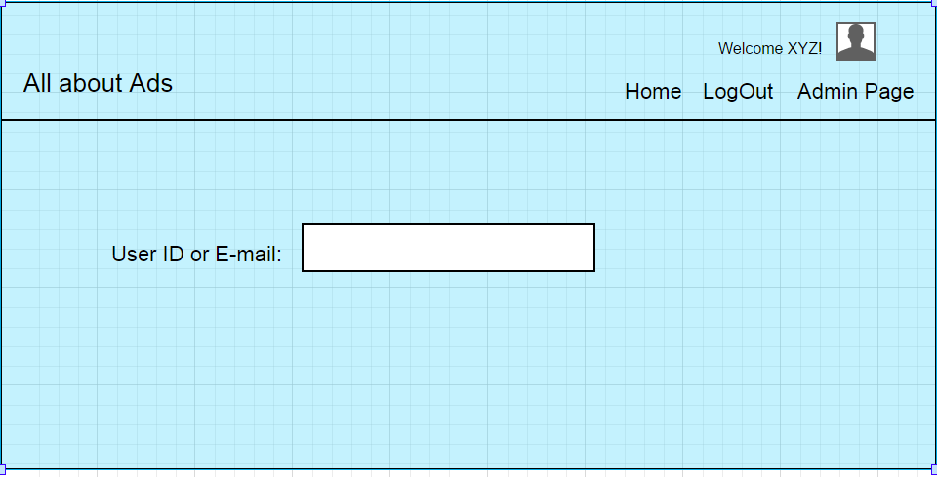

Suppose the user is a new user and wishes to register, he is redirected to a new page where the details are to be filled in.

**4.4 Ask New Question**

Each User can ask question and submit that he can give the detailed of the question and also give tag to the question.

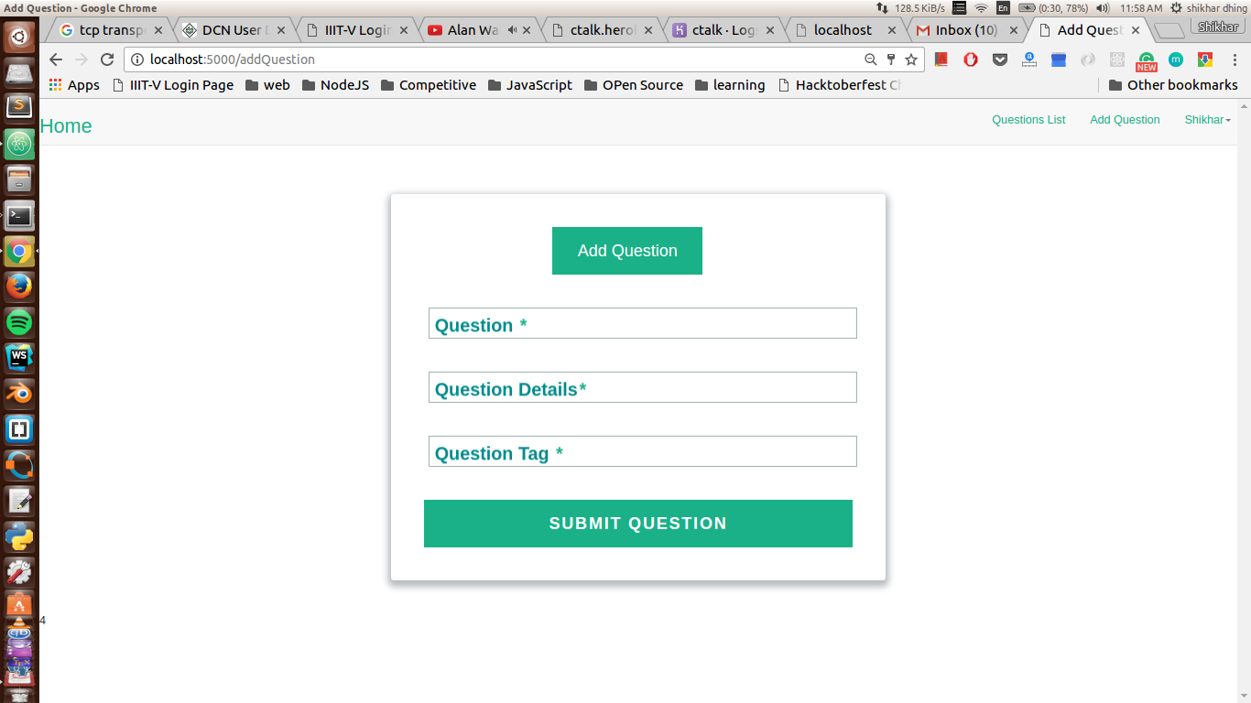

**4.5 View Profile**

In the user Profile user can change password and see his Topic of Interest. Each user can change his Topic of interest.

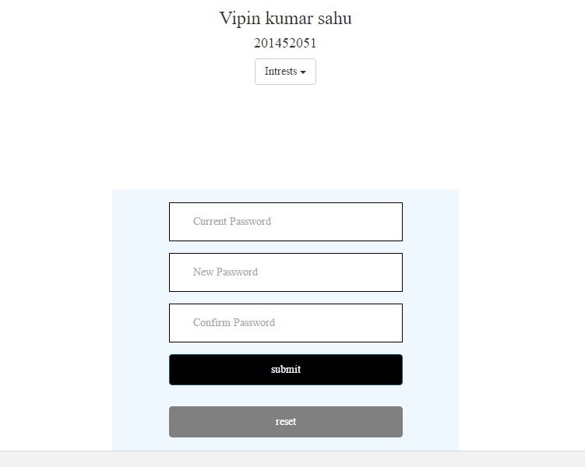

1. **Frequently Asked Questions (FAQ)**
2. How to create a Profile?

* Open Chrome -> Enter the url: - ctalk.herokuapp.com
* Submit your Email ID.
* Login with your credentials.
* Then choose The TOI which provided in the Window.
* Fill the required fields and click on Save to successfully create your Profile

.

1. How to change password?

* Open Chrome -> Enter the url: - ctalk.herokuapp.com
* Login with your credentials.
* Click on the profile link available at the top right corner of the Homepage. You will be redirected to Change Password page.
* Enter your old password and new password and click on Submit. You will be redirected to the Homepage.

1. What procedure to follow if I forget my password?

* Open Chrome -> Enter the url: - ctalk.herokuapp.com
* Click on the “Forgot Password?” link. You will be redirected to the Forgot Password page.
* Enter your E-mail address. A mail will be sent to the email address you are registered with which will contain a new one-time password.
* Login with that one-time password.
* Click on the Change Password option available at the top right corner of the Homepage. You will be redirected to Change Password page.
* Enter the one-time password and new password and click on Submit. You will be redirected to the Homepage.

1. **References**
2. High level design document v1.0, Team 04, IT303 Software Engineering, Summer 2015, IIIT Vadodara.